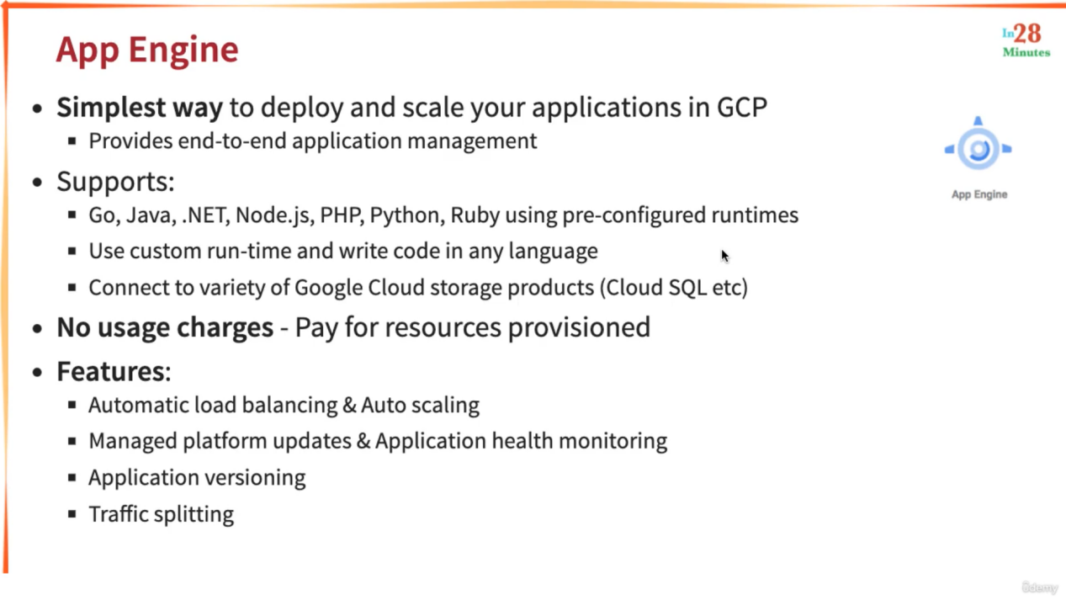

You can run containers in App Engine. We can connect with Google Databases and Queues from App Engine. App Engine manages multiple Application versions and manages traffic among them.

If you have a Simple java or Python application you can deploy it into App Engine. If you want to add a GPU, you can not do it using App Engine.

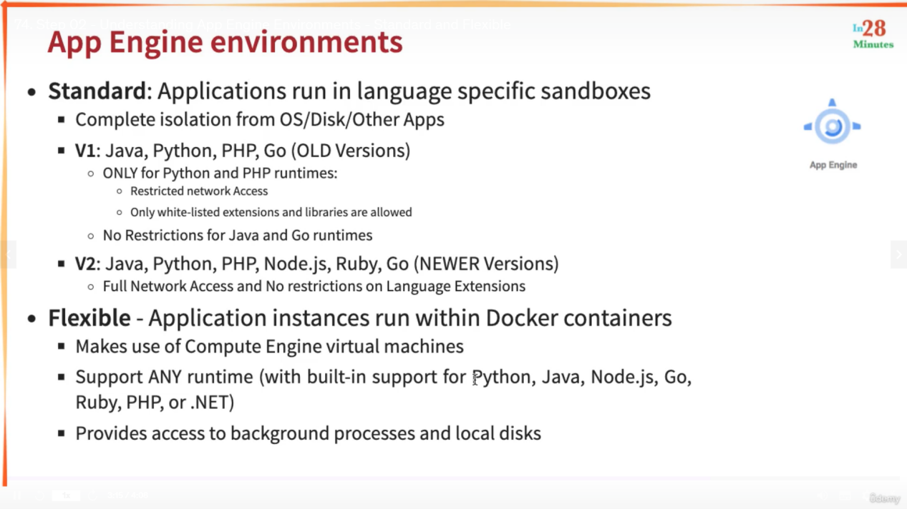

App Engine Standard run application in language specific sandboxes. With App Engine Flexible we can get access to background processes and also we can attach local disks.

In AppEngine we need to Know Application-> Service-> Version.

Application acts as a container for all the services that you want to run. We can create one Application per project. If we have three Microservices we will create three services for each of the MS.

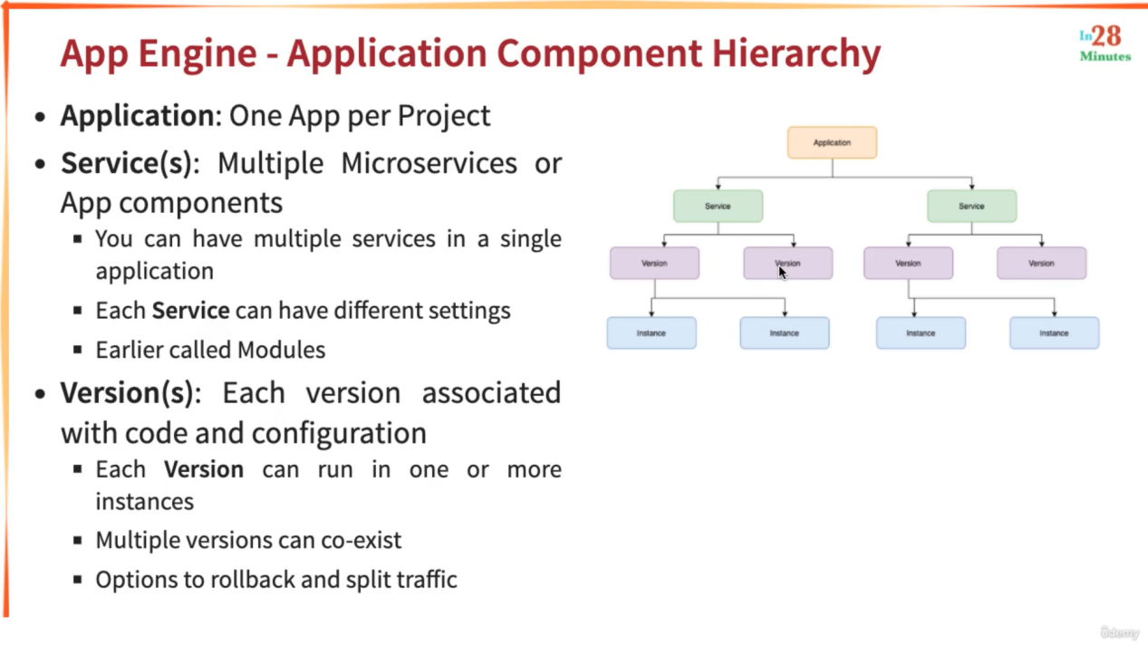

Scaling

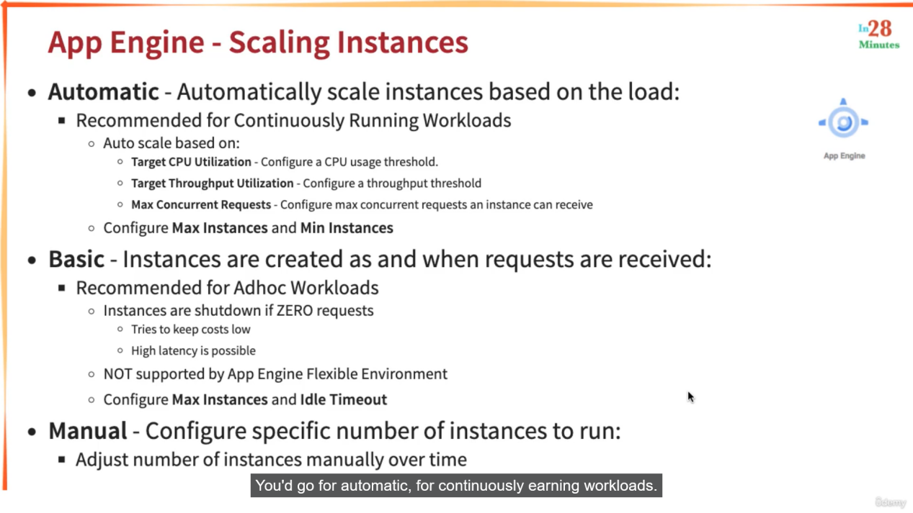

Commands

1. cd default-service
2. gcloud app deploy
3. gcloud app services list
4. gcloud app versions list
5. gcloud app instances list
6. gcloud app deploy --version=v2
7. gcloud app versions list
8. gcloud app browse (give link of the active version)
9. gcloud app browse --version 20210215t072907
10. gcloud app deploy --version=v3 --no-promote (no-promote will not route traffice to that instance version but starts that instance)
11. gcloud app browse --version v3
12. gcloud app services set-traffic split=v3=.5,v2=.5
13. gcloud app services set-traffic splits=v3=.5,v2=.5
14. watch curl https://melodic-furnace-304906.uc.r.appspot.com/
15. gcloud app services set-traffic --splits=v3=.5,v2=.5 --split-by=random
17. cd ../my-first-service/
18. gcloud app deploy
19. gcloud app browse --service=my-first-service
21. gcloud app services list
22. gcloud app regions list
24. gcloud app browse --service=my-first-service --version=20210215t075851
25. gcloud app browse --version=v2
26. gcloud app open-console --version=v2
27. gcloud app versions list --hide-no-traffic (only active versions will be displayed)

Deploying an Application in App Engine Standard

If you delete a project, whatever is configured will also be deleted.

Create a new Project

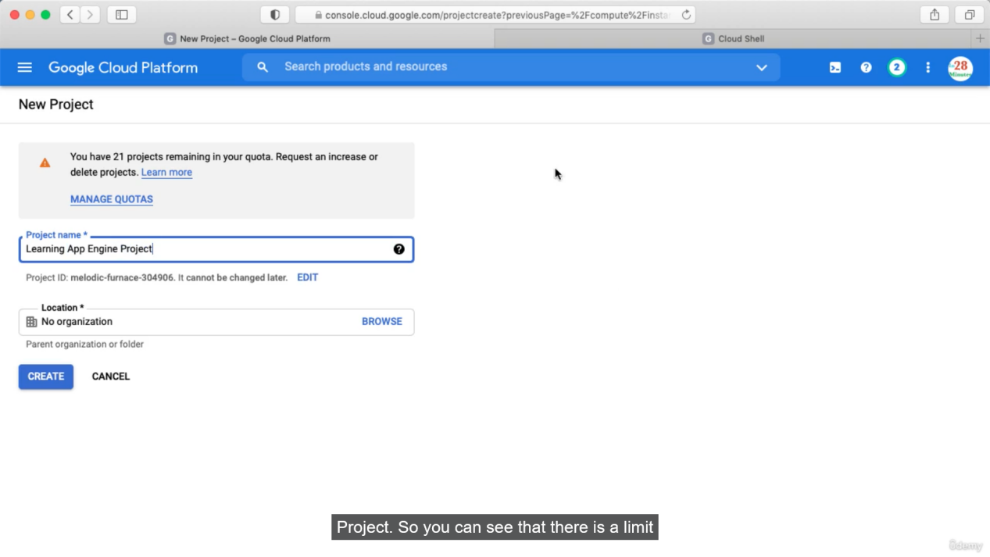

Now we need to give permission to App Engine API

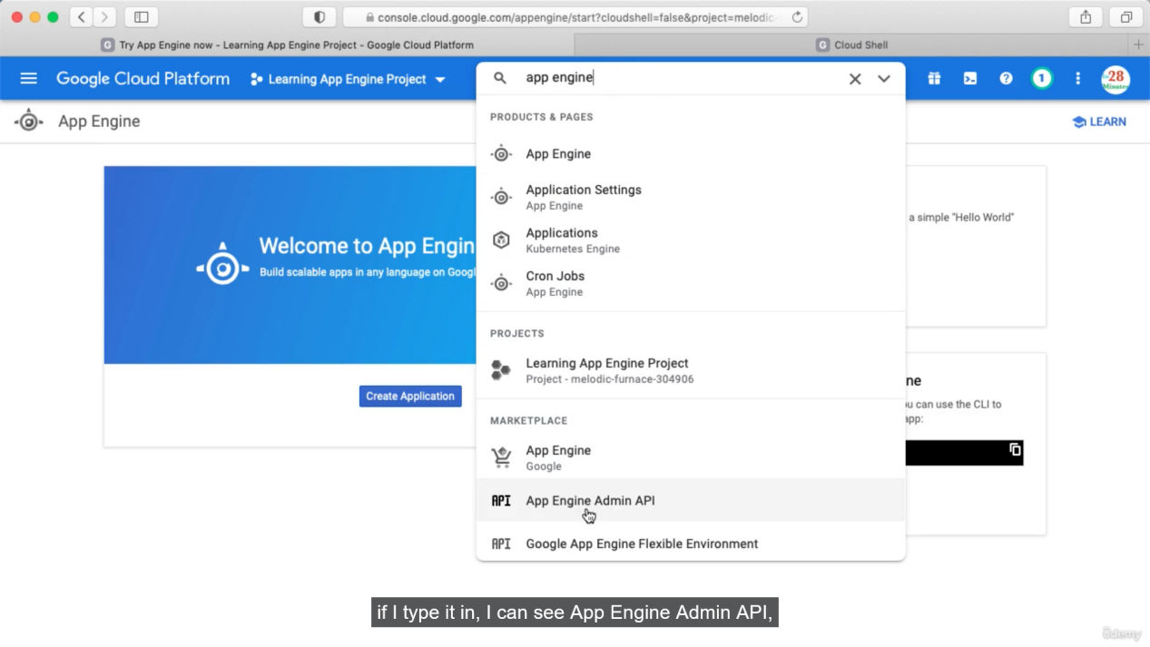

Click Enable. This is one time activity.

Now we need to create App Engine **Aplication** first. This will act as a conaner and inside one project we can have only one App Engine Application.

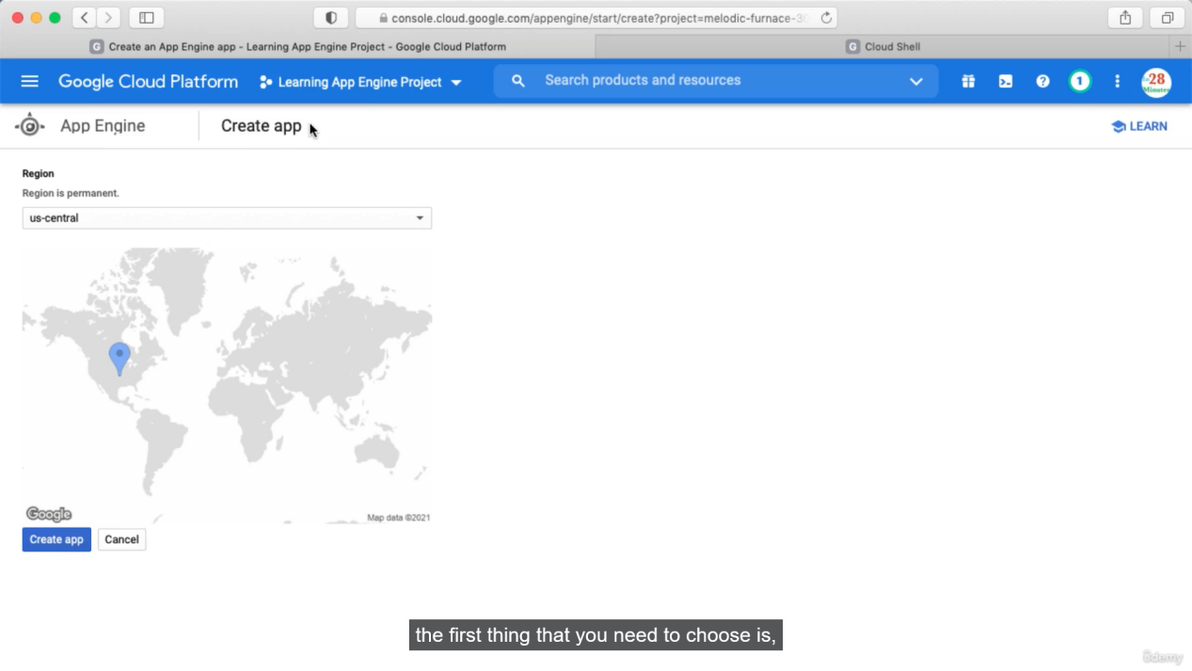

This application is region specific. If we want to choose multiple regions then we need to create multiple projects.

Now we need to choose the Language and runtime.

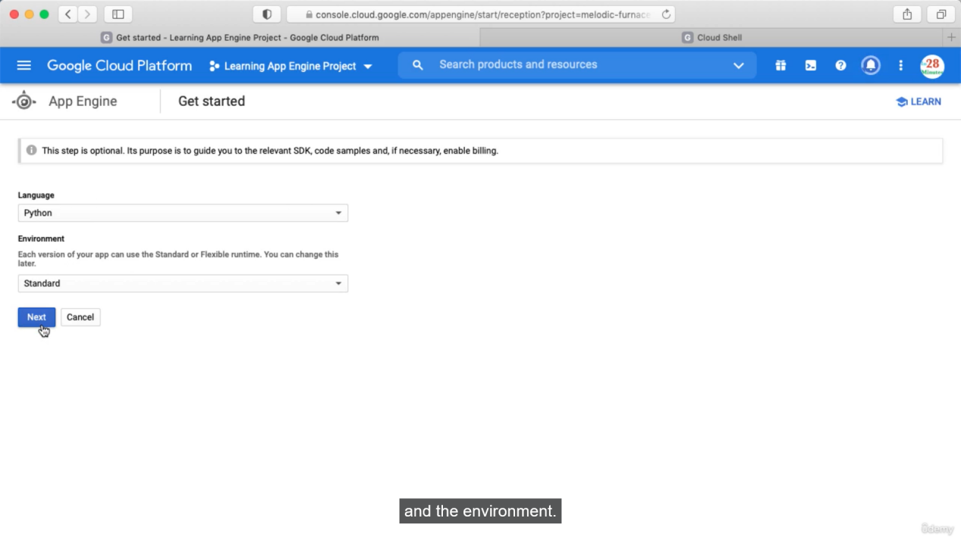

This will create the sandbox for you. Now we need to deploy our application.

Go to cloud shell

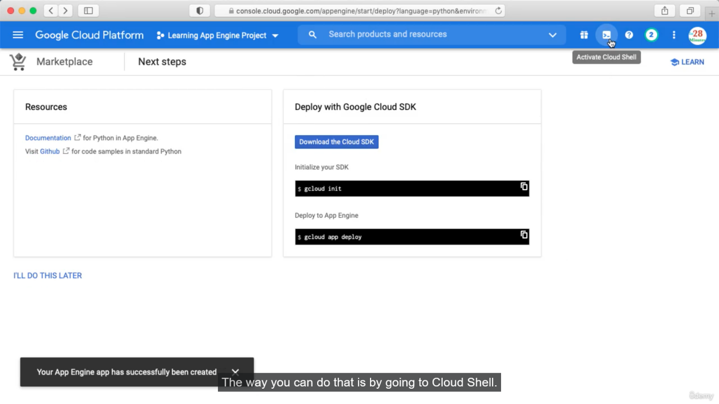

Click open Editor -> open in new window. You will see below where you can write you code or drag drop your code and also you can see command prompt.

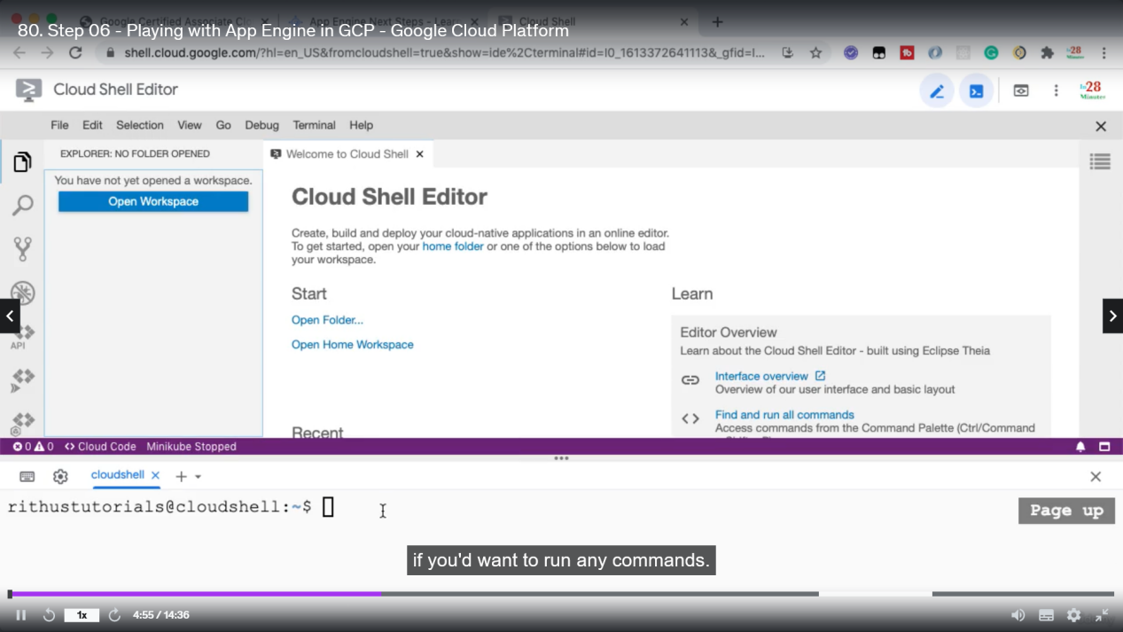

Click open folder and choose home folder

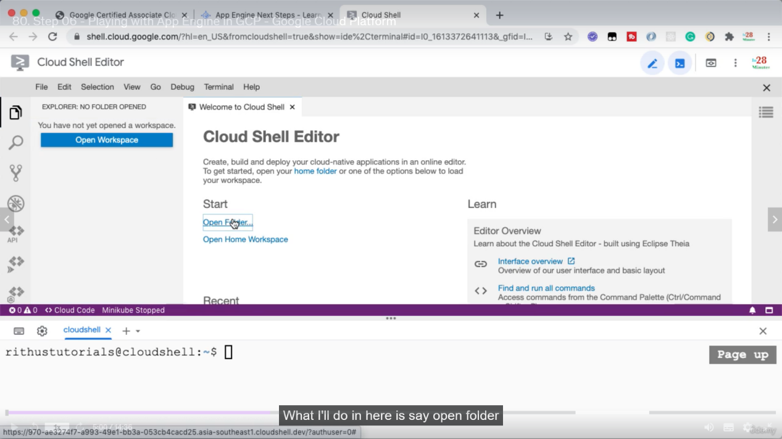

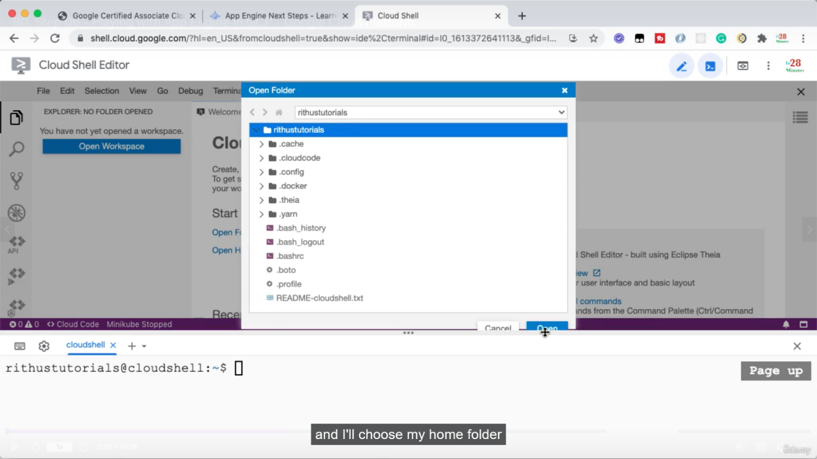

Now drag drop you project

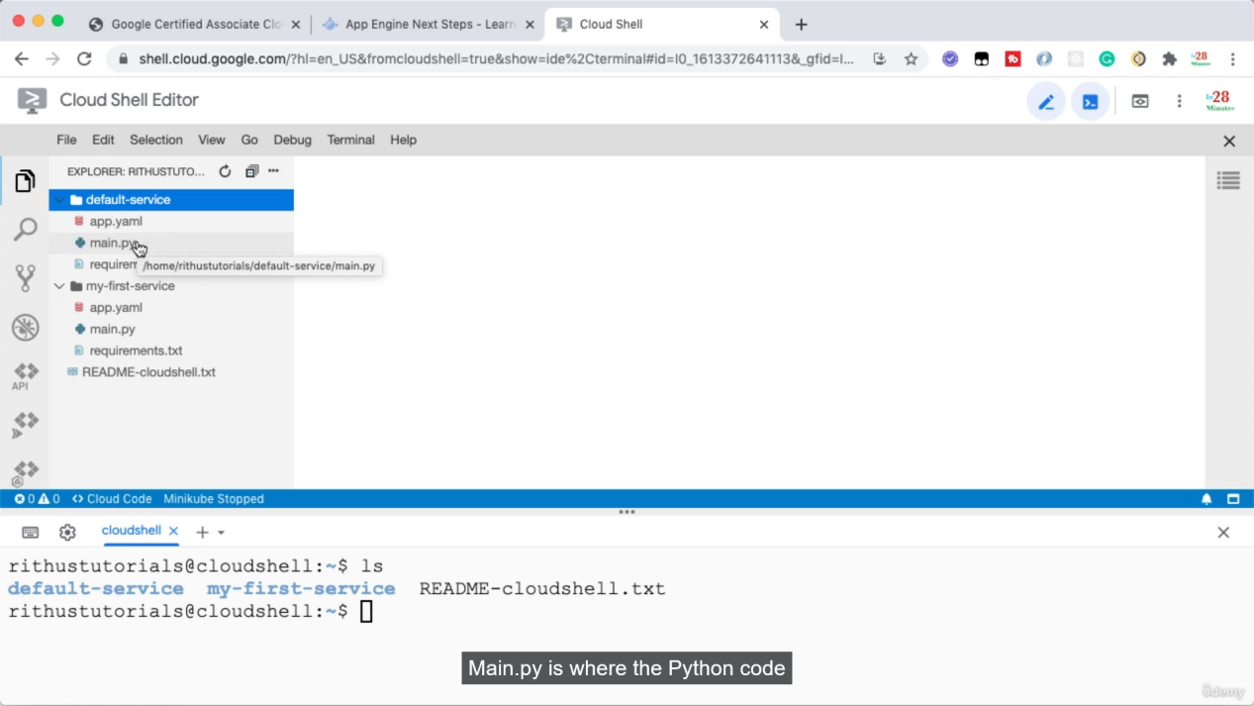

In terminal set your project

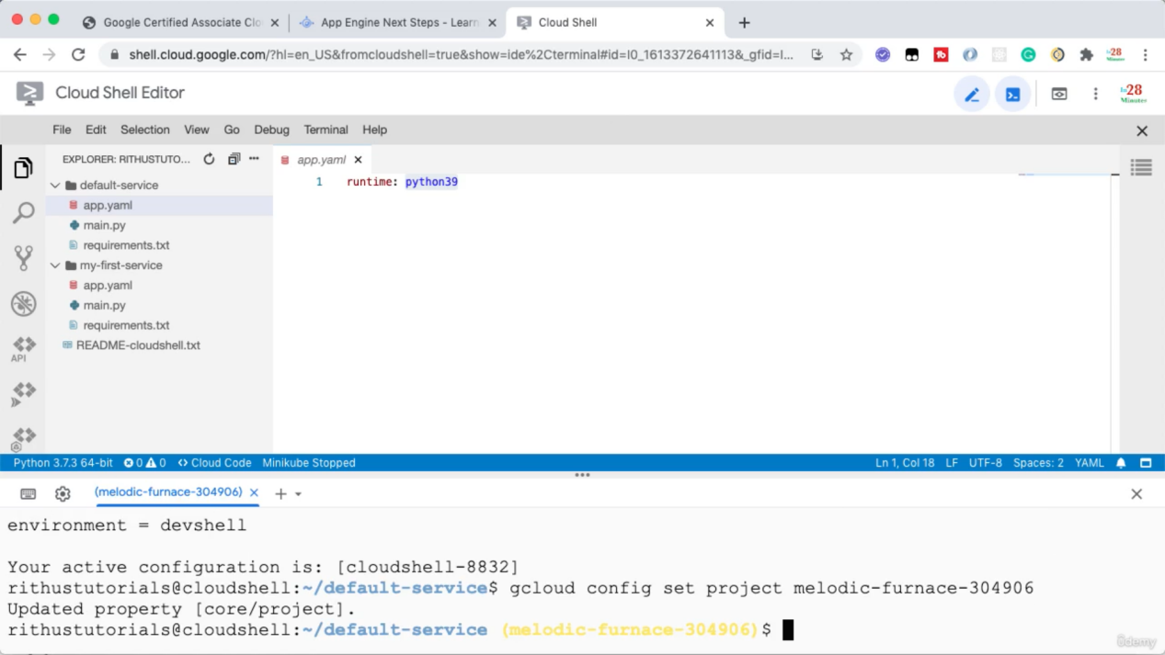

In terminal you have to select the path where the app.yaml is kept. Generally its in direct project directory. In app.yaml we have the application runtime defined.

Run gcloud app deploy => or gcloud app deploy app.yaml file name default is app.yaml

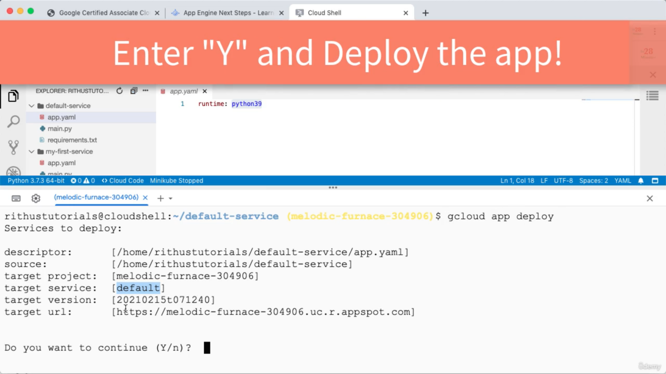

One of the service in the Application is the target service. While running you will get an error

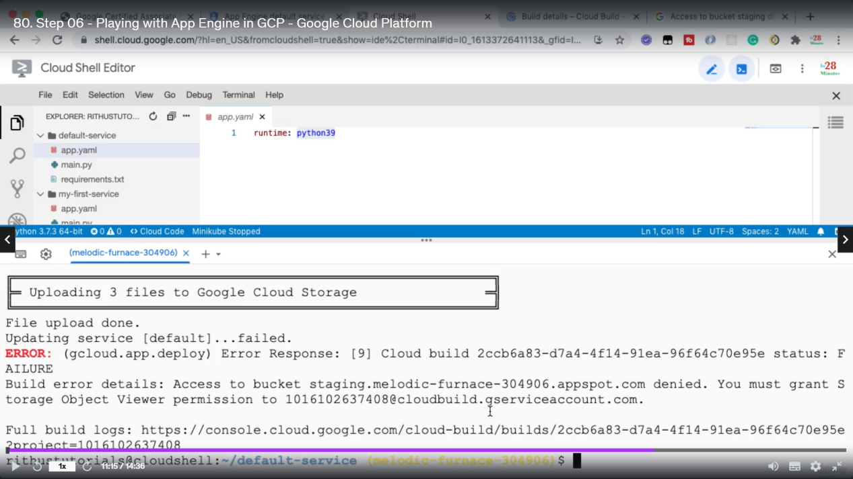

Go to IAM and give permission o that bucket.

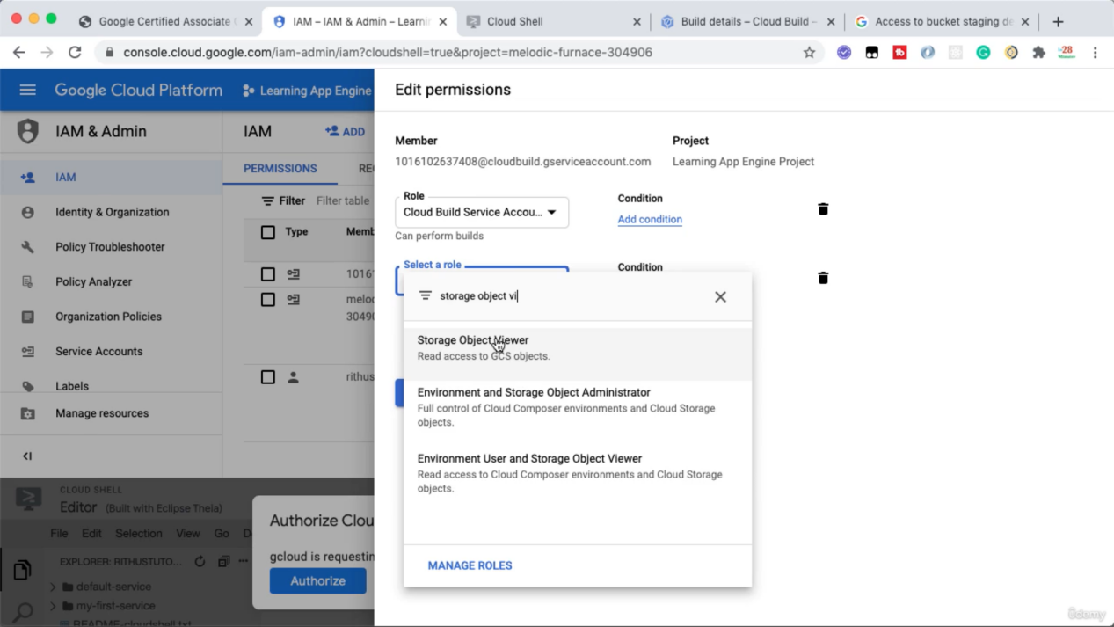

Whenever we deploy a service a deployment package is created and is stored into a bucket in Google storage. We need to give permission so that App Engine can access it.  
Now if we open App Engine We will see the details about the deployment.

In the services you can create the service

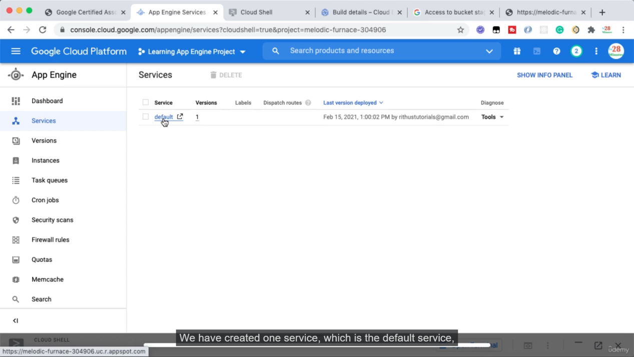

In the version tab you can see the version which is serving the traffic.

From terminal also you can get different data

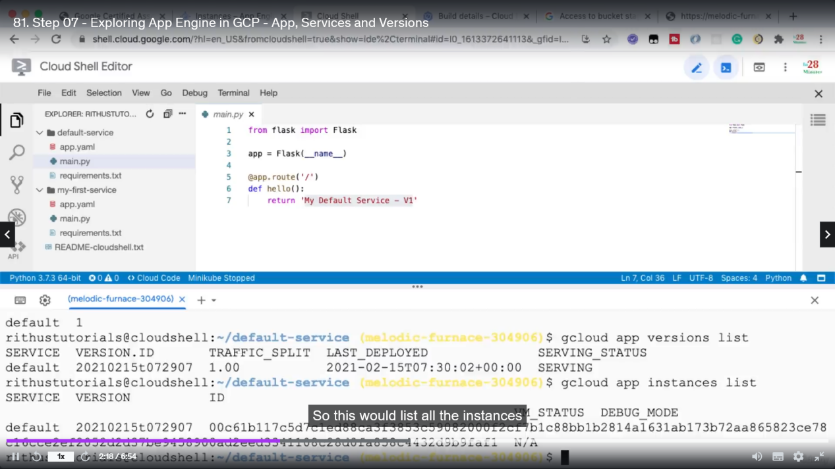

Now make some change to your code and deploy it, then you see the target version is now v2

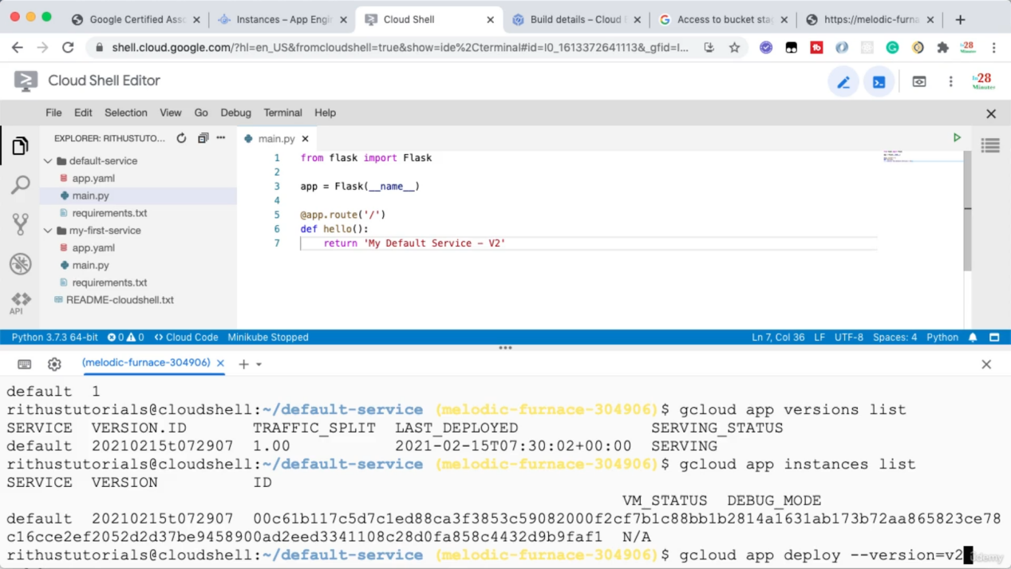

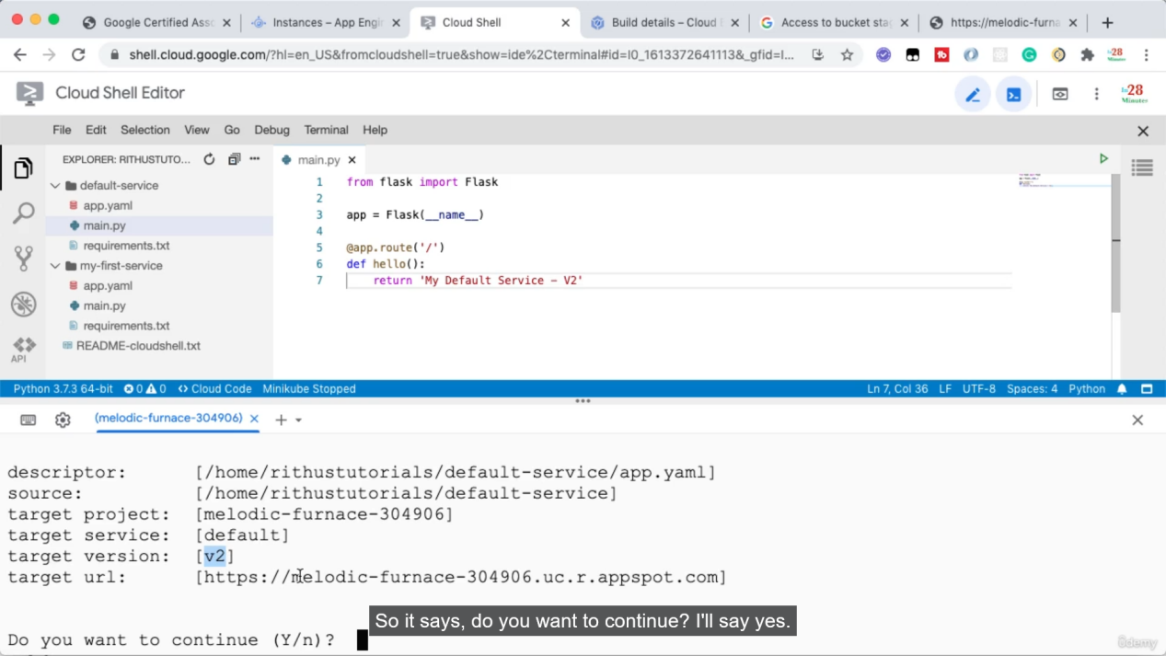

Now after deployment all traffice is moved to V2 but V1 is still running

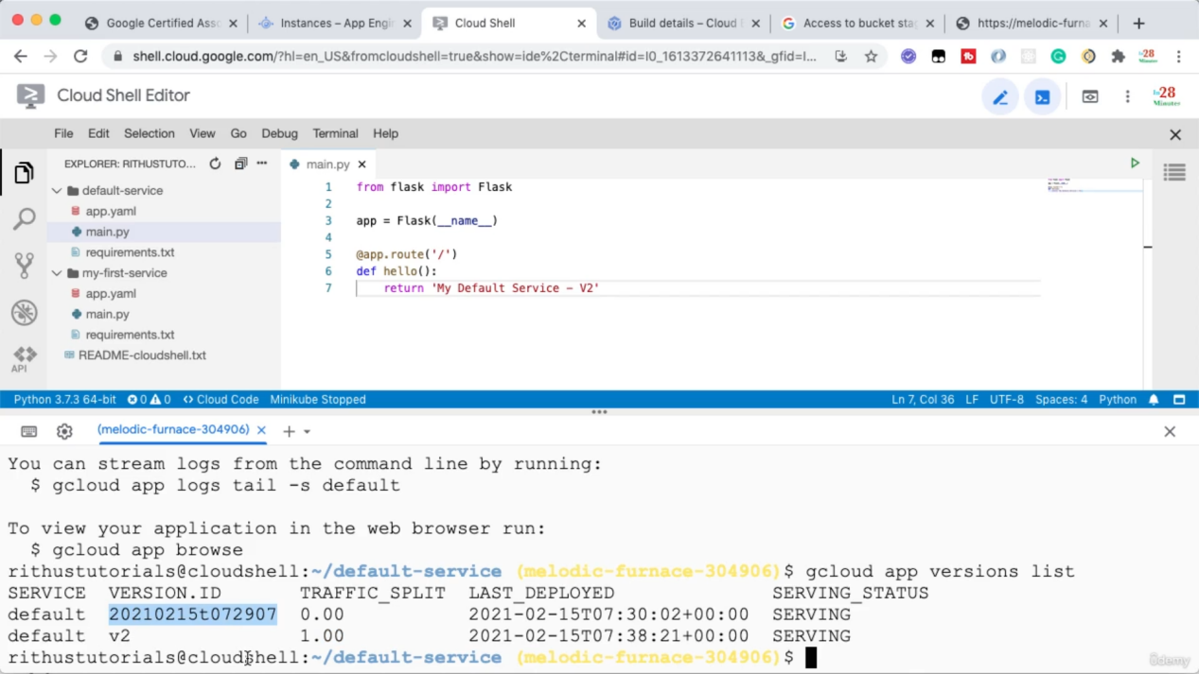

I want to find url for a version

Gcloud app browse => will give you link for active version

Gcloud app browse --version 20210215t072907

(check the difference between active and other versions)

Splitting traffic between multiple versions

Change something into your code. => gcloud app deploy --version=v3 --no-promote

This will deploy and start the new version but does not switch traffic into it.

You can get the url for v3 and test it.Splitting can be done by below command.

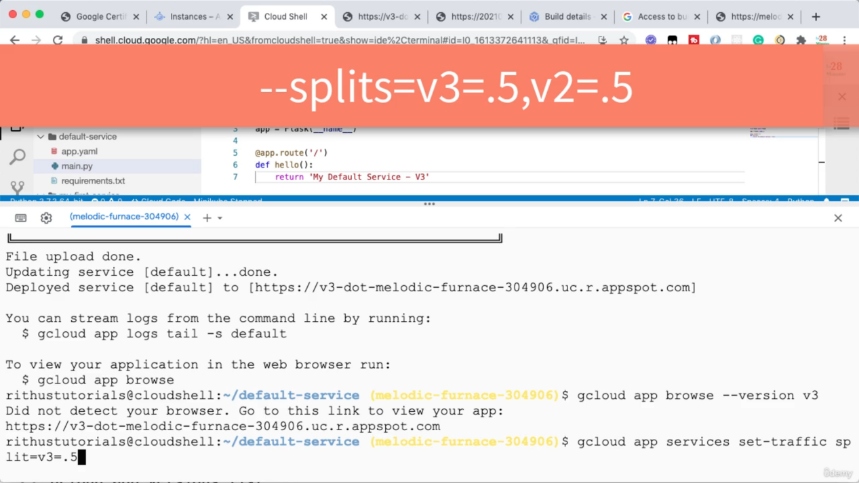

You can use => watch curl url. (curl will send get request in every 2 seconds.)

As we are splitting by ip address and we are hitting from our own ip it will serve from same version.

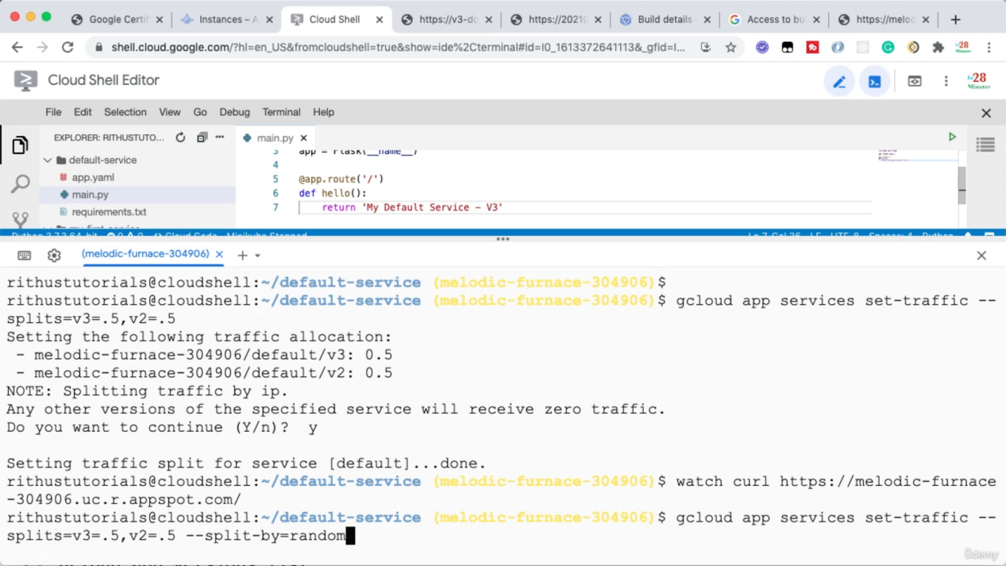

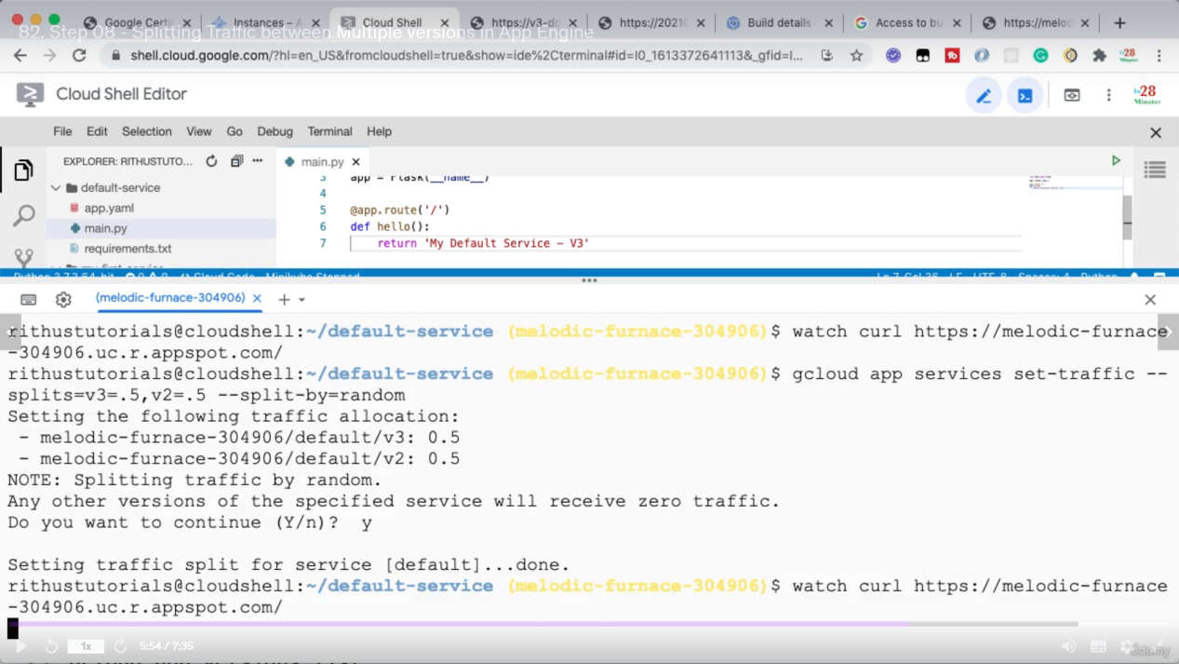

Creating a new service

From ui also we can split traffic

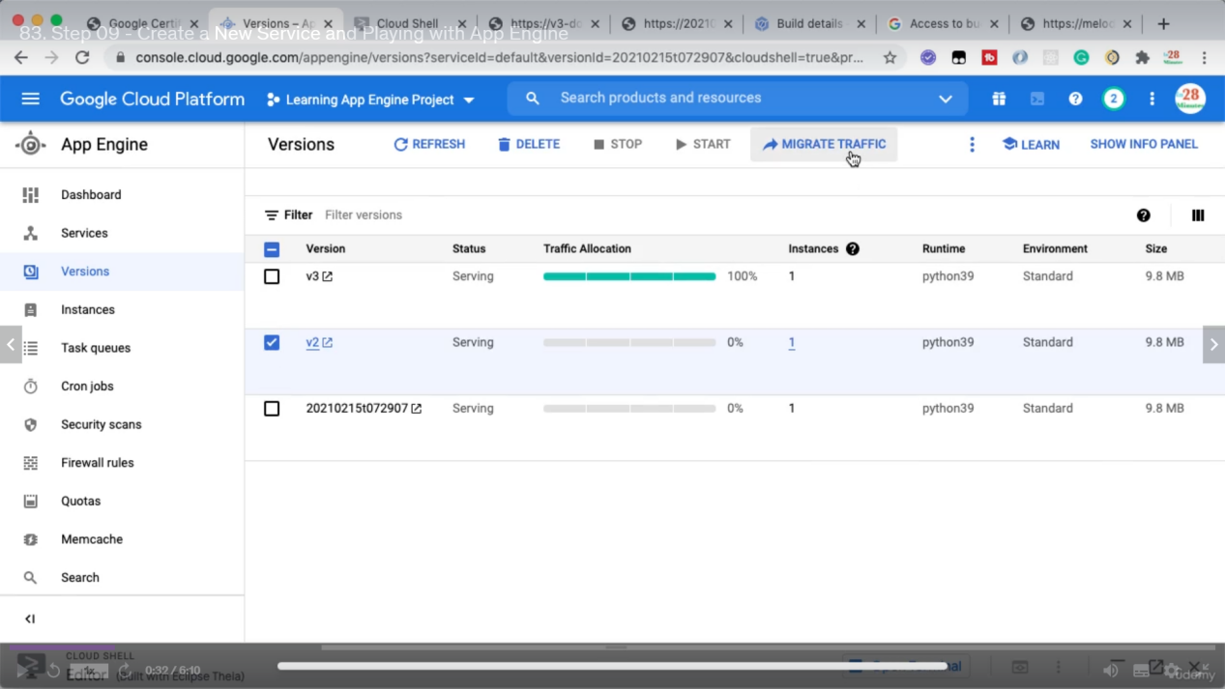

Click triple dot => Split traffic

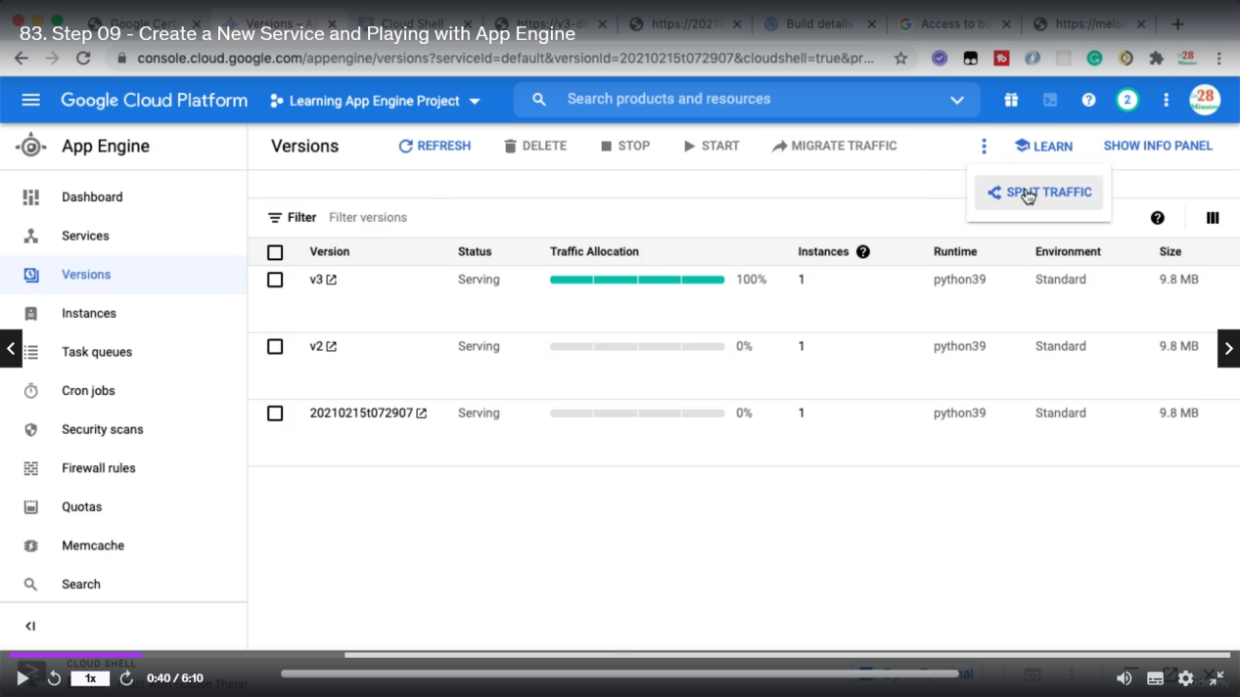

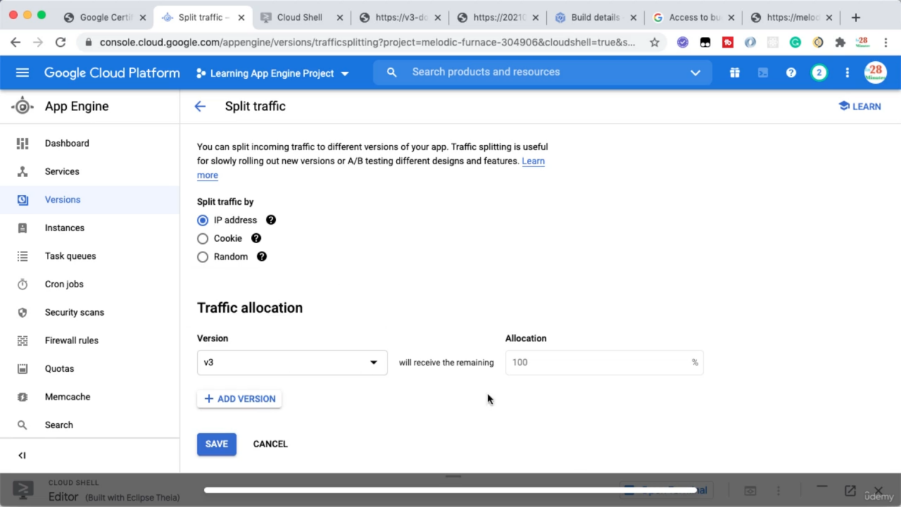

Creating a new Service with a service name => change it into app.yaml and deploy it

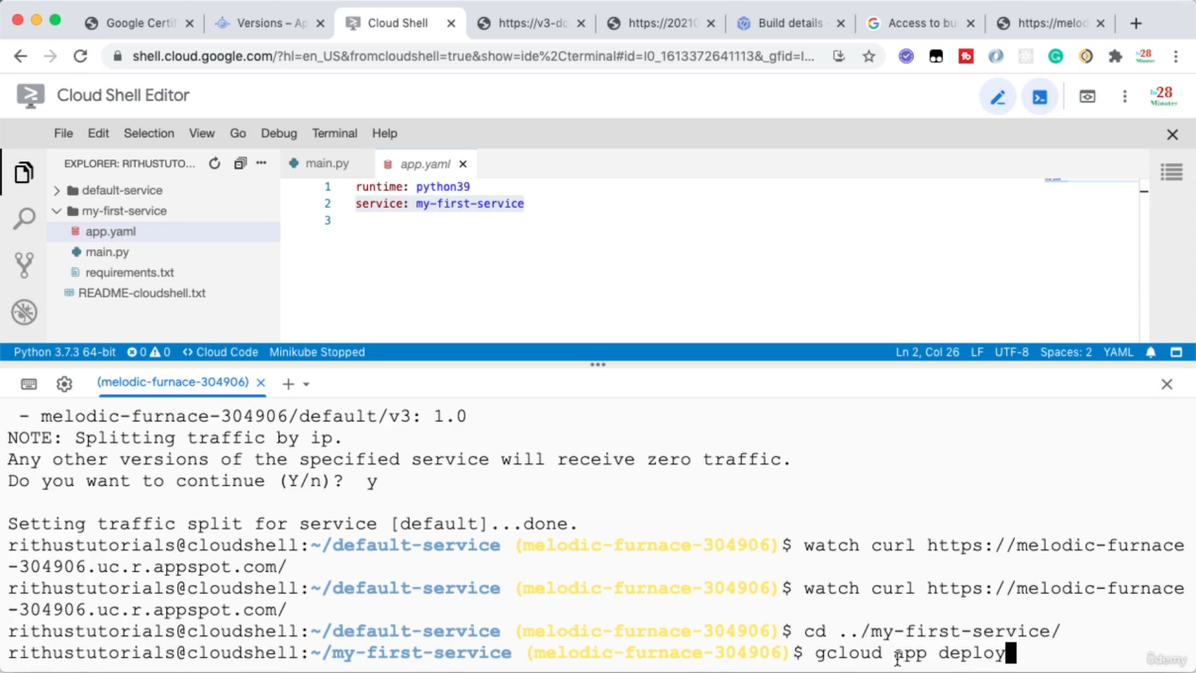

You can have different url for the same service as below

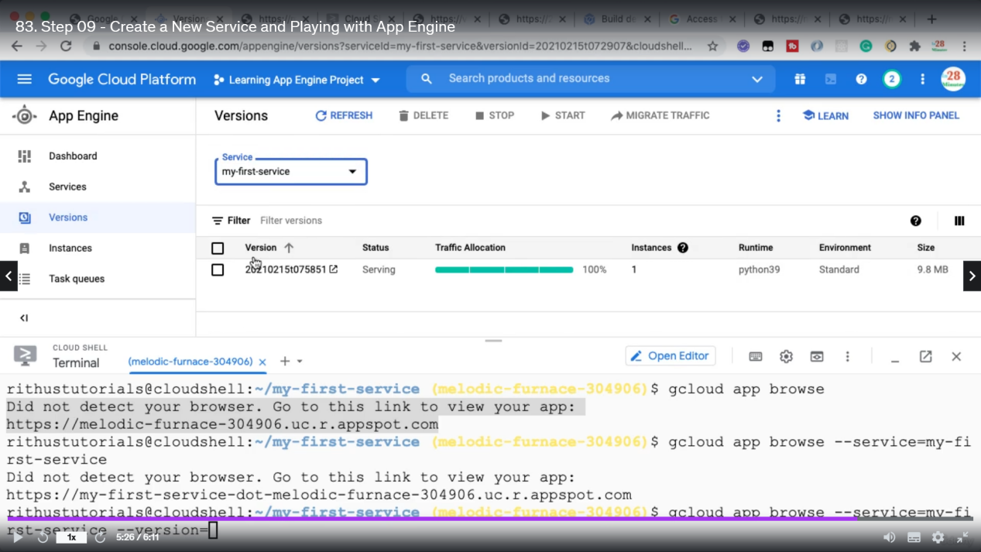

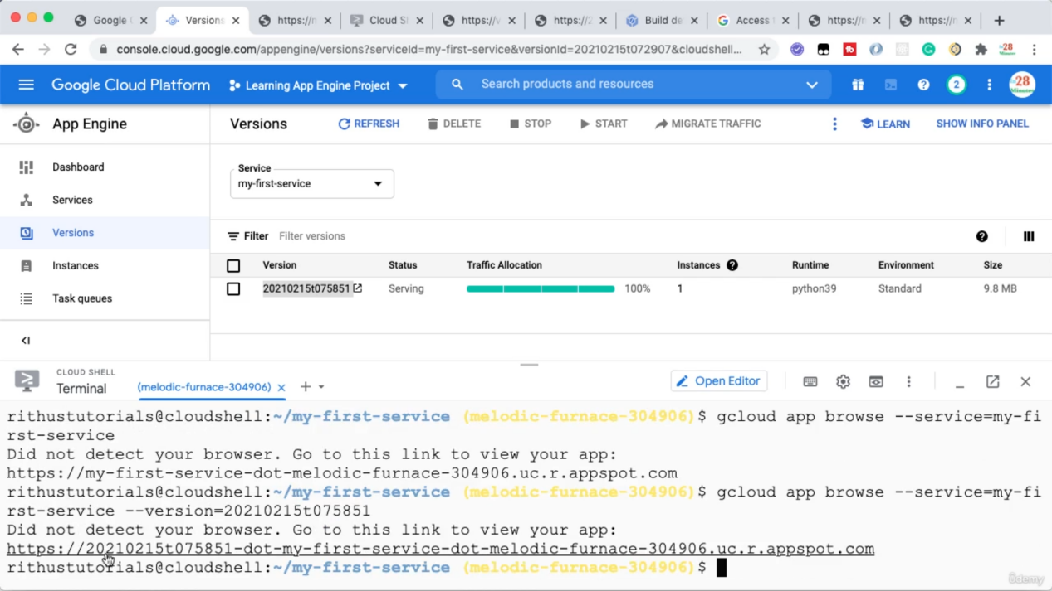

App.yaml details

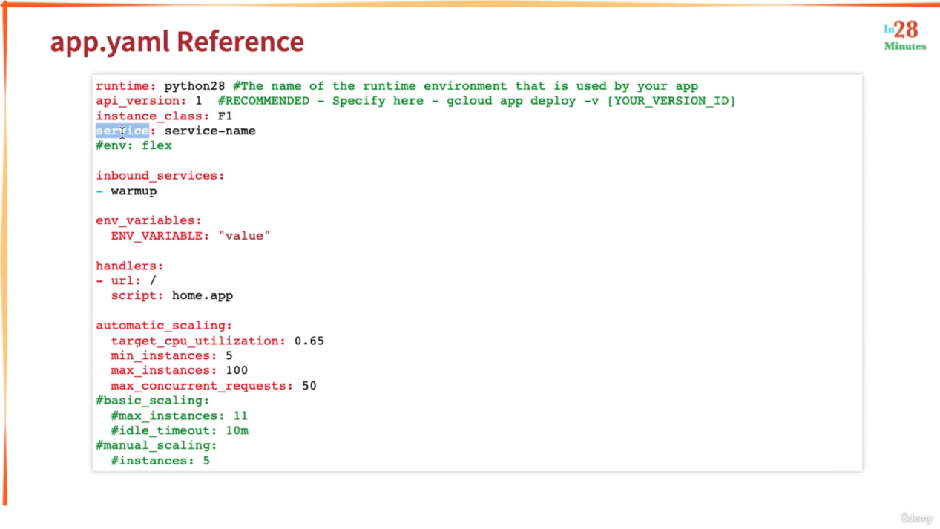

Env: flex => will use app Engine flexible and use containers

Routing traffic in different kinds of url

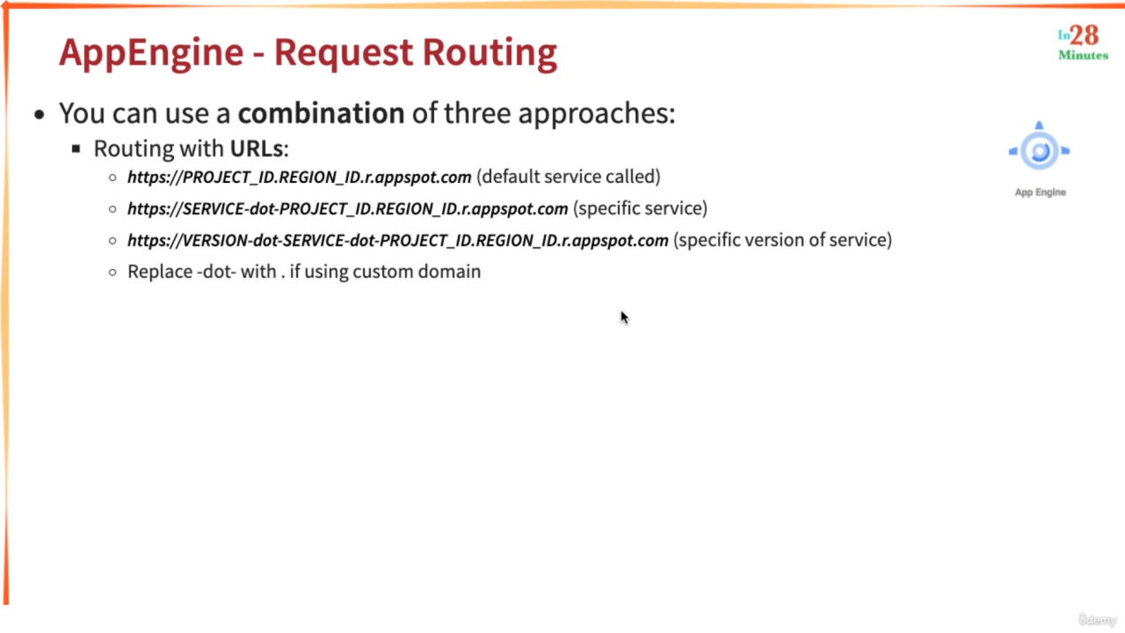

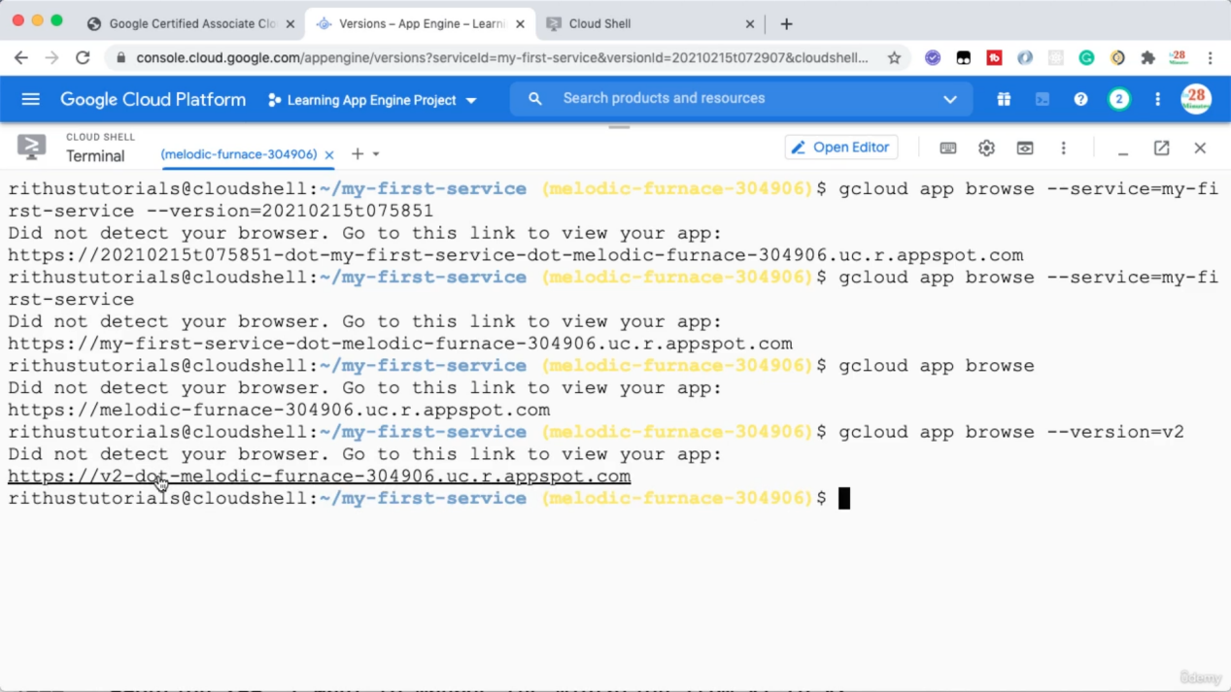

You also can create your custom domain

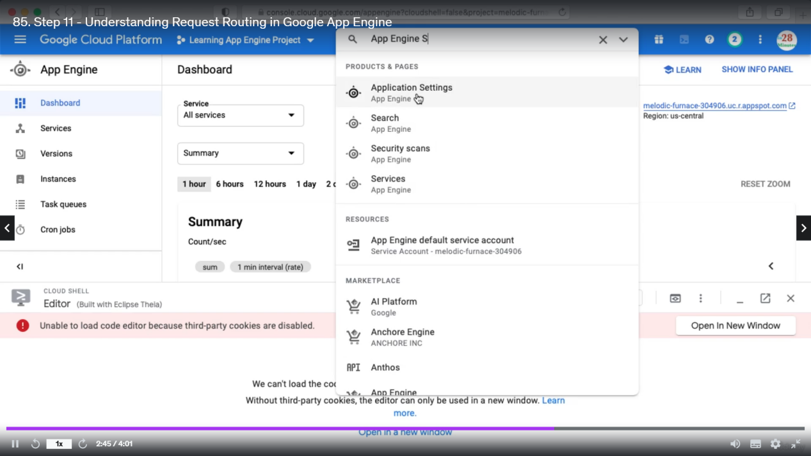

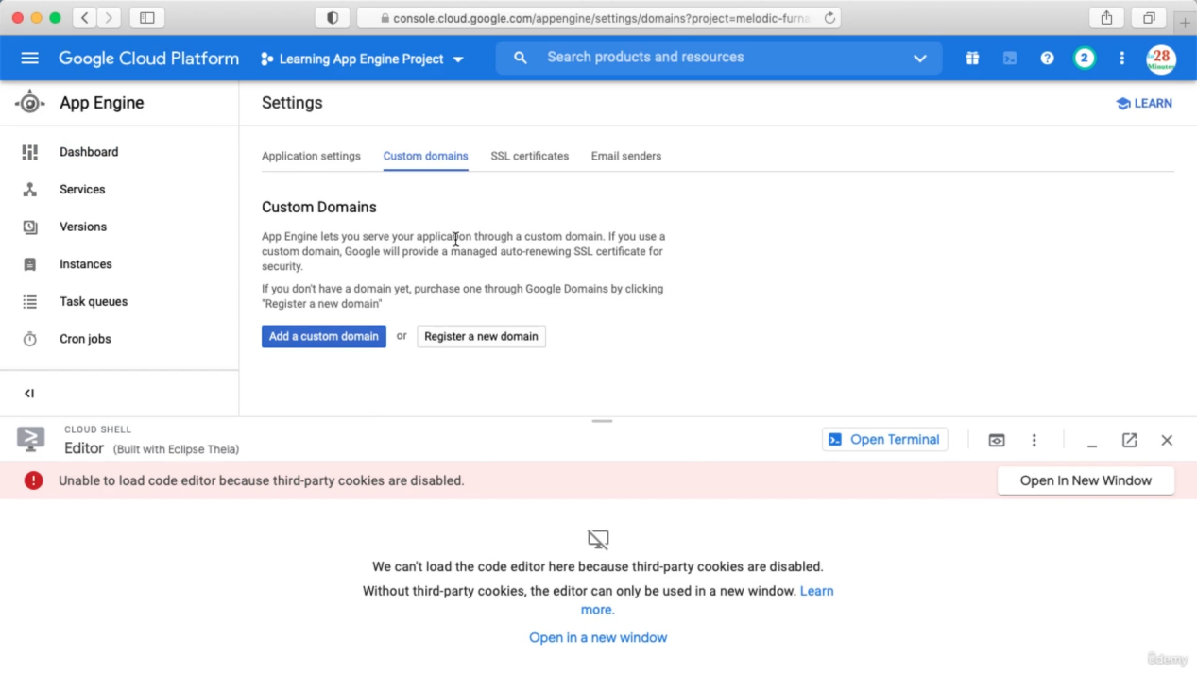

Do not create

You can also configure dispatch.yaml. Where you can specify if the request comes from this url dispatch to this service.

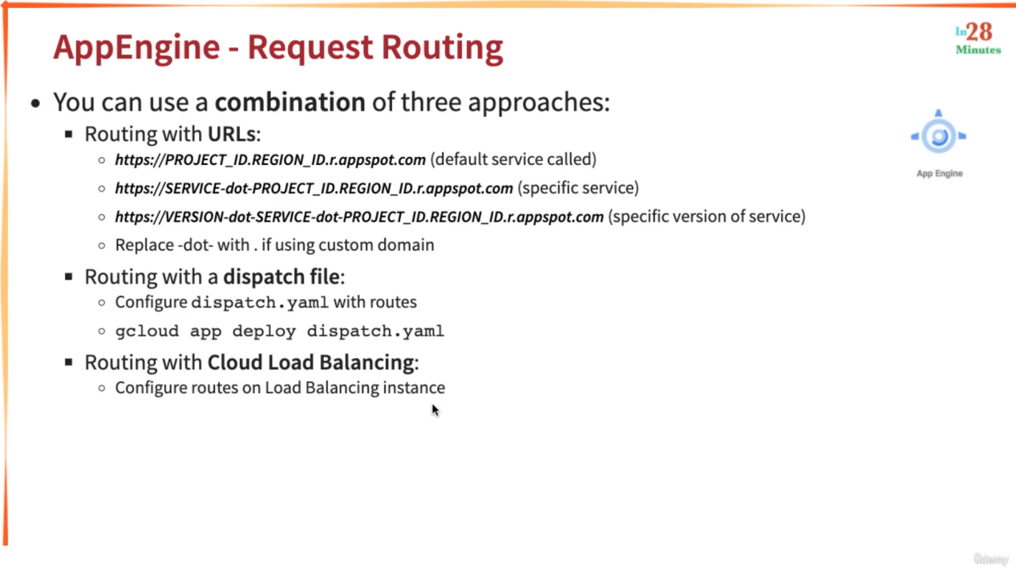

Deploying new App Engine Version without downtime

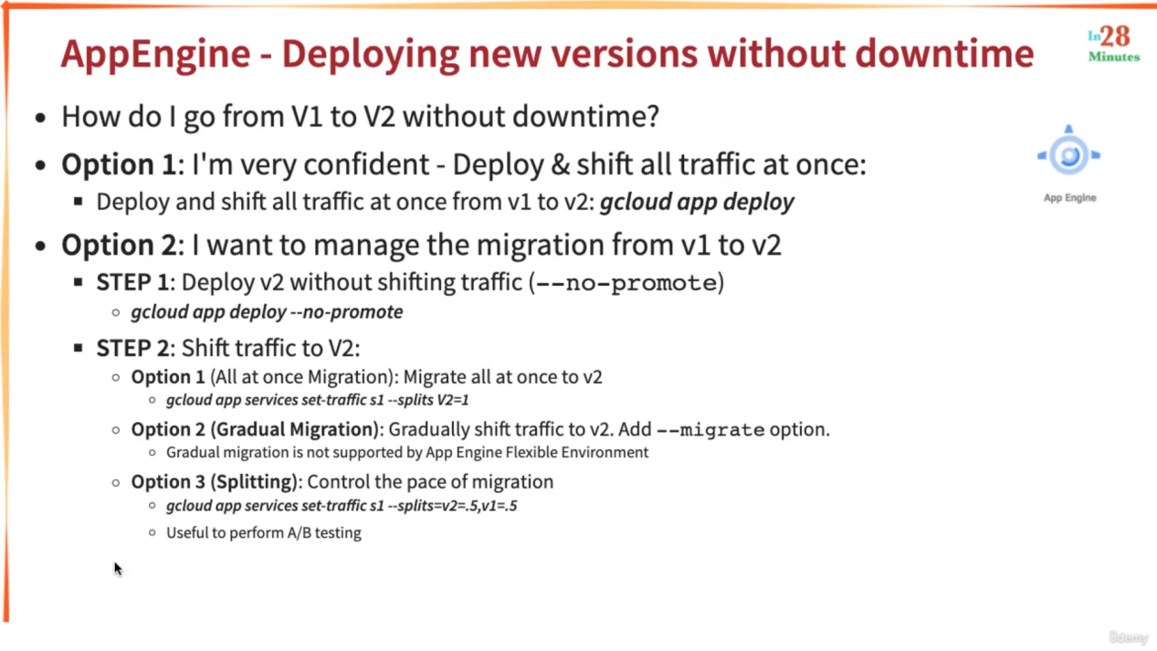

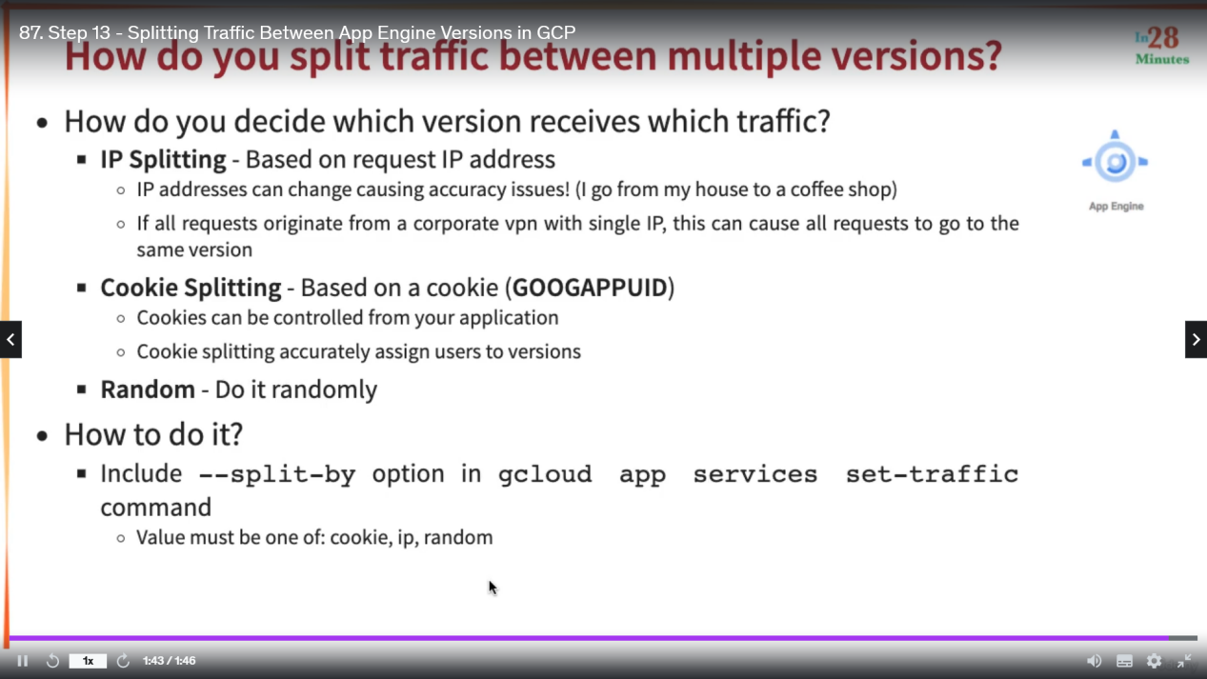

Common commands

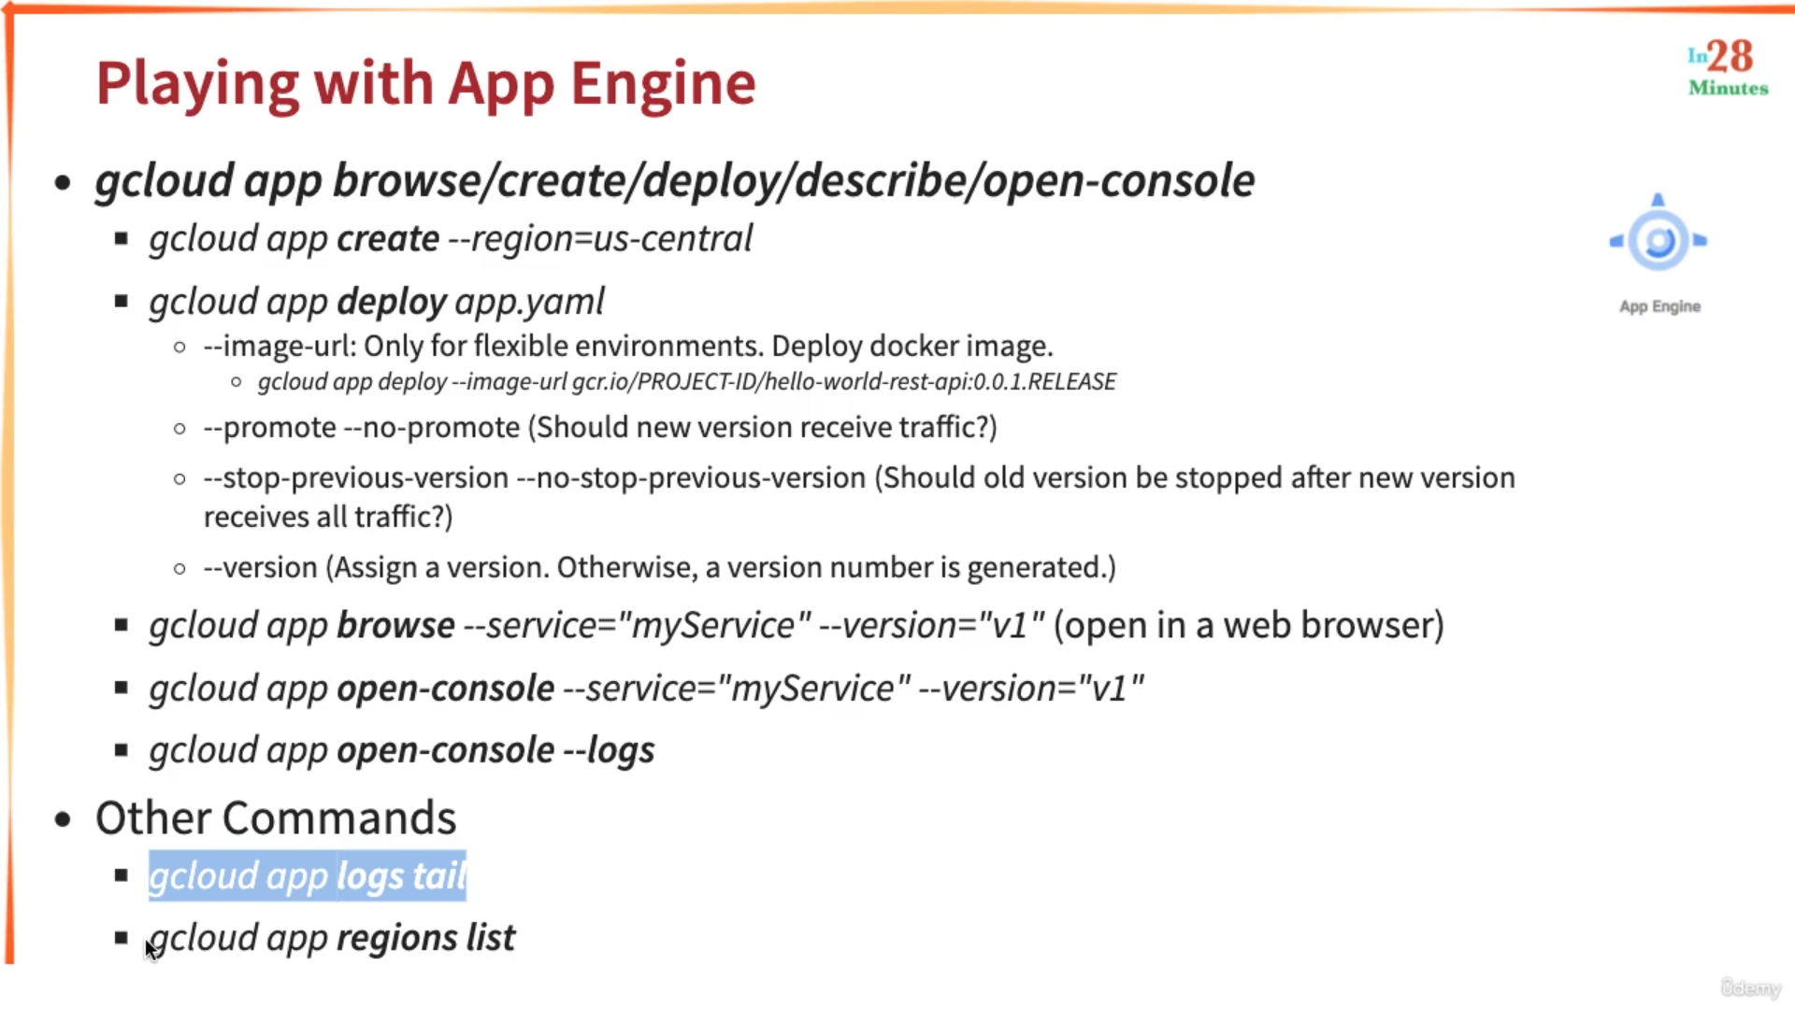

Gcloud app open-console --service=”my-service” => this will open the corresponding service in Google App Engine Web.

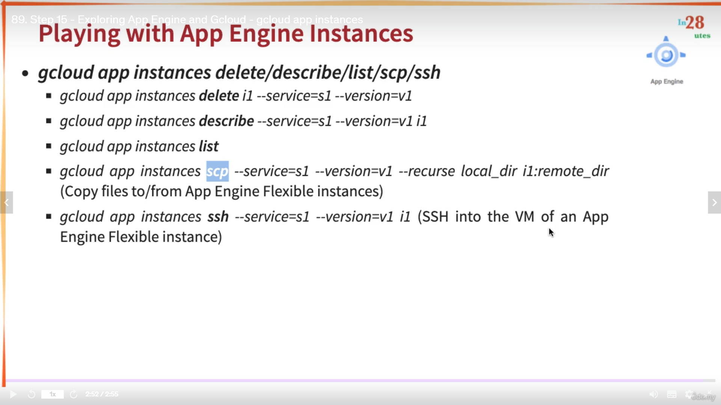

Gcloud app instances list => will list down all the instances, for App Engine Standard if there are not much load the instances scale down to zero.

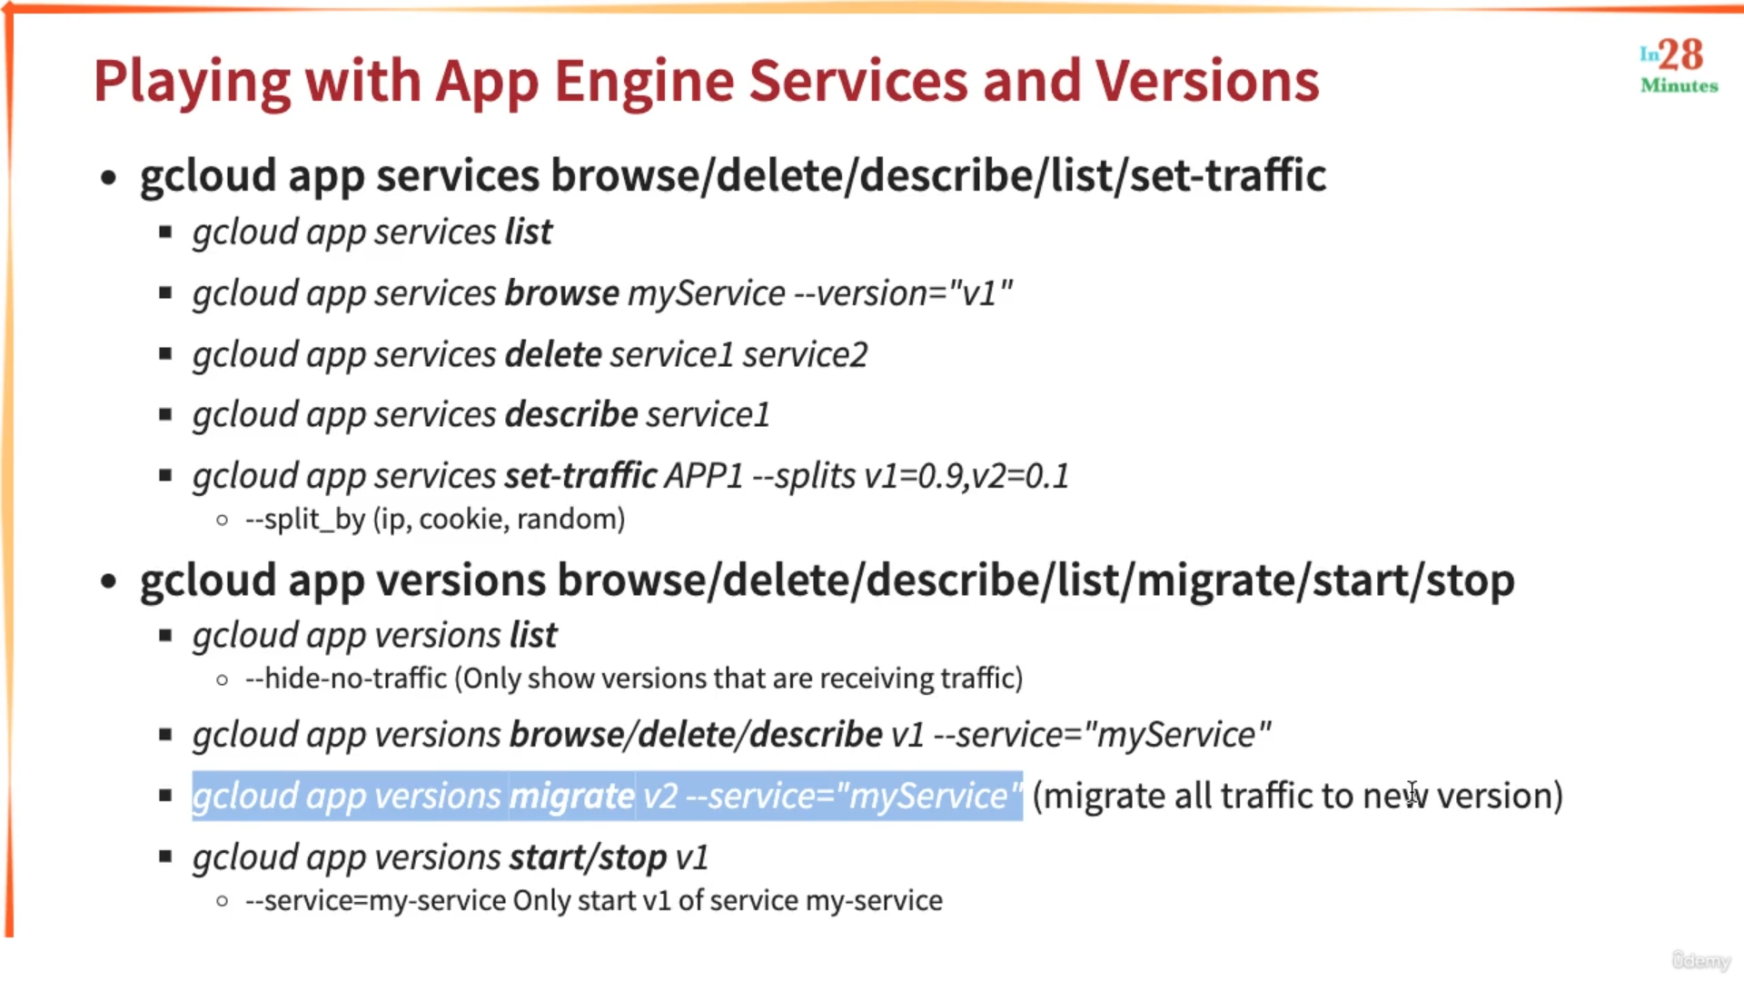

Creating cron job

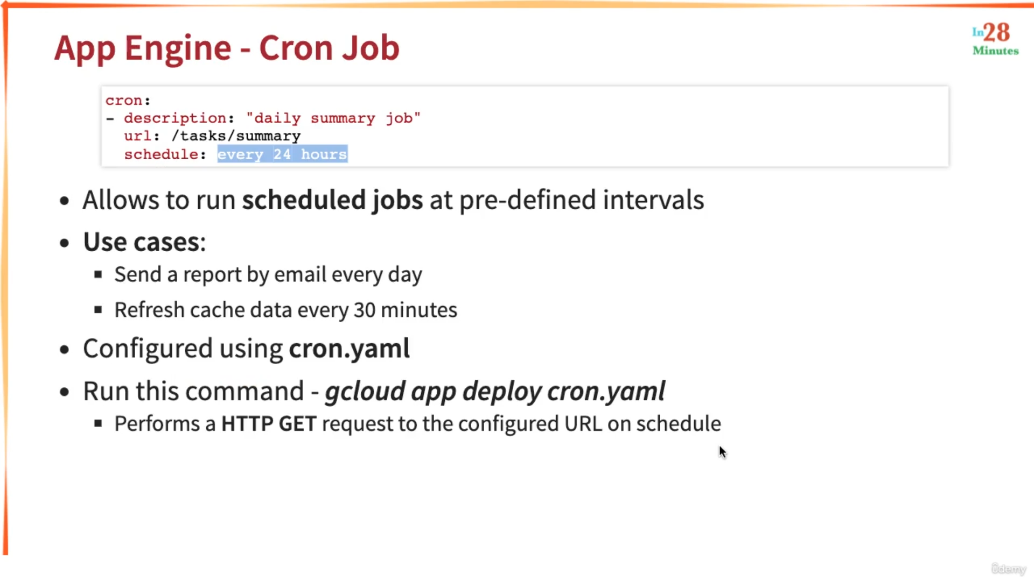

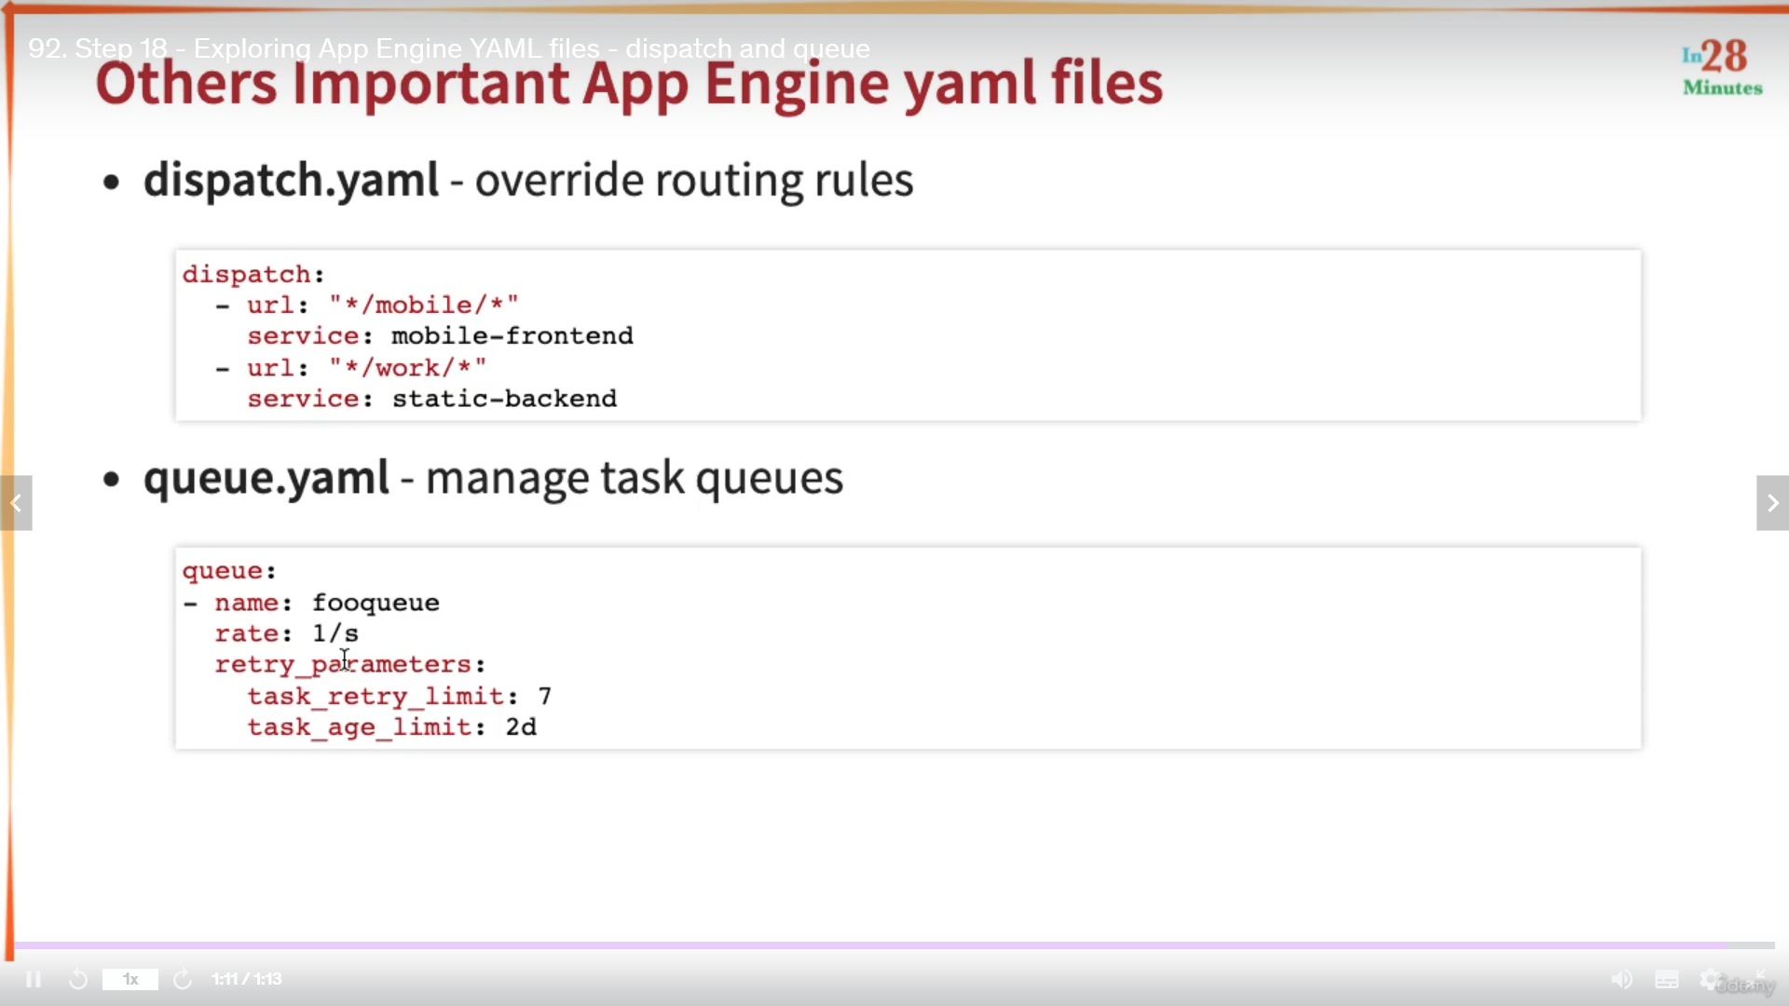

Gcloud app deploy dispatch.yaml will deploy it.

Important things to remember

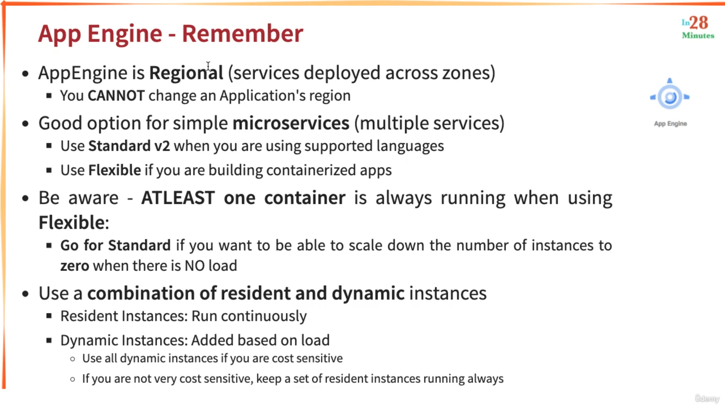

Scenarios

